A heuristic, or heuristic technique, is any approach to problem solving or self-discovery that employs a practical method that is not guaranteed to be optimal, perfect, or rational, but is nevertheless sufficient for reaching an immediate, short-term goal or approximation.

Knowledge-based agents are those agents who have the capability of maintaining an internal state of knowledge, reason over that knowledge, update their knowledge after observations and take actions. These agents can represent the world with some formal representation and act intelligently. Logical Representation, Semantic Network Representation Frame Representation, Production Rules

First-order logic is another way of knowledge representation in artificial intelligence. It is an extension to propositional logic. FOL is sufficiently expressive to represent the natural language statements in a concise way. First-order logic is also known as Predicate logic or First-order predicate logic.

Well Formed Formula(WFF) is a finite sequence of symbols from a given alphabet that is part of a formal language. A formal language can be identified with the set of formulas in the language.

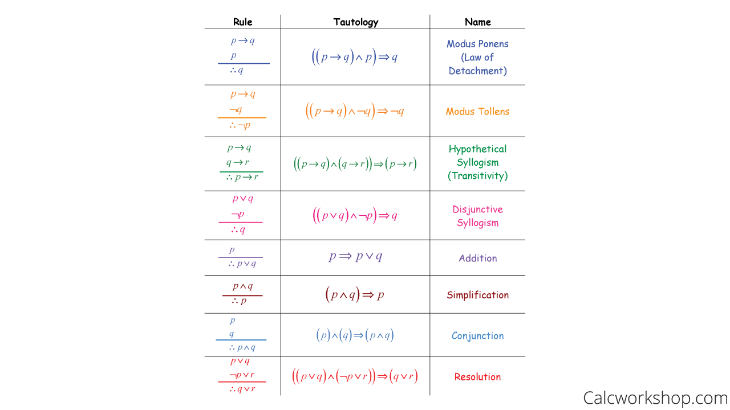Inference Rule The arguments are chained together using Rules of Inferences to deduce new statements and ultimately prove that the theorem is valid.



Forward chaining starts from known facts and applies inference rule to extract more data unit it reaches to the goal. Bottom-up approach. Backward chaining starts from the goal and works backward through inference rules to find the required facts that support the goal. top-down approach.

Resolution method is also called Proof by Refutation/contradiction

Convert the given axiom into clausal form, i.e., disjunction form.

Apply and proof the given goal using negation rule.

Use those literals which are needed to prove.

Solve the clauses together and achieve the goal.

Fuzzification: It is the method of transforming a crisp quantity(set) into a fuzzy quantity(set). This can be achieved by identifying the various known crisp and deterministic quantities as completely nondeterministic and quite uncertain in nature.

Defuzzification: It is the inverse of fuzzification. The former one was used to convert the crisp results into fuzzy results but here the mapping is done to convert the fuzzy results into crisp results. This process is capable of generating a non-fuzzy control action which illustrates the possibility distribution of an inferred fuzzy control action.

A frame is a record like structure which consists of a collection of attributes and its values to describe an entity in the world. Frames are the AI data structure which divides knowledge into substructures by representing stereotypes situations. It consists of a collection of slots and slot values.

Bayes’ Theorem describes the probability of an event, based on precedent knowledge of conditions which might be related to the event. In other words, Bayes’ Theorem is the add-on of Conditional Probability.

A Bayesian network (BN) is a probabilistic graphical model for representing knowledge about an uncertain domain where each node corresponds to a random variable and each edge represents the conditional probability for the corresponding random variables.

Conditional probability is defined as the likelihood of an event or outcome occurring, based on the occurrence of a previous event or outcome. Conditional probability is calculated by multiplying the probability of the preceding event by the updated probability of the succeeding, or conditional, event.

NLP stands for Natural Language Processing, which is a part of Computer Science, Human language, and Artificial Intelligence. It is the technology that is used by machines to understand, analyse, manipulate, and interpret human's languages.

NLP Advantages

* NLP helps users to ask questions about any subject and get a direct response within seconds.
* NLP offers exact answers to the question means it does not offer unnecessary and unwanted information.
* NLP helps computers to communicate with humans in their languages.
* It is very time efficient.

Membership functions allow you to quantify linguistic term and represent a fuzzy set graphically. A membership function for a fuzzy set A on the universe of discourse X is defined as μA:X → [0,1]. Here, each element of X is mapped to a value between 0 and 1